Indian School Al Wadi Al Kabir
Unit Test 1
SOCIOLOGY (Code:039)
Class: XI Time: 1 Hour
Date:28/05/2023 Max. Marks: 30
General Instructions:

1. The question paper is divided into three sections.
2. There are 16 questions in all. All questions are compulsory.
3. Section A includes question No. 1-10. These are objective type questions carrying 1mark each
4. Section B includes question No. 11-13. These are very short answer type questions carrying 2
marks each. Answer to each question should not exceed 80 words.
5. Section C includes question No.14-15. They are short answer type questions carrying 4
marks each. Answer to each question should not exceed 120 words.
6. Section D includes question No.16. They are long answer type questions carrying 6 marks
each. Answer to each question should not exceed 300 words. There’s an internal choice in Sections B, C&D. Please write answers on selected questions only.

 | SECTION A
1. | _______ and ______ became the defining principles during the Enlightenment Movement.  - Liberty and fraternity b. solidarity and equal rights  - individualism and rational thought d. equality and freedom | 1
2. | A class of students is not an example of an aggregate. Correct and rewrite the statement. | 1
3. | Sociology is the study of modern societies whereas social anthropology is the study of primitive societies. Correct and rewrite the statement. | 1
4. | ______ is an extreme form of inequality in which a person is completely owned by another person. (Choose the correct word and fill in the blank)  - Poverty b. Caste c. slavery d. discrimination | 1
5. | Sociology is a categorical science, not a normative science because it deals with ‘what is’ instead of ‘Who ought to be’. State whether True/False | 1
6. | Assertion (A): During an inter school football match between ISWK and ISM, the spectators witnessing a match cheer for their respective school teams.  Reason (R): In groups are characterized by a sense of belonging, a sense of ‘us’ and ‘we’ and anyone not a member of tis group is perceived as ‘they’  - Both A & R are true and R is the correct explanation of A  - Both A & R are true but R is not the correct explanation of A  - A is true but R is false  - A is false but R is true | 1
7. | Who categorized classes based on their relationship to the means of production?  - Emile Durkheim b. Max Weber c. August Comte d. Karl Marx | 1
8. | Assertion (A): People who migrated from rural areas to work in factories of the big cities had very sophisticated living conditions.  Reason (R): In many parts of the world, industrialization resulted in urbanization.  - Both A & R are true and R is the correct explanation of A  - Both A & R are true but R is not the correct explanation of A  - A is true but R is false  - A is false but R is true | 1
9. | Secondary groups are relatively small in size and characterised by impersonal relationships. State whether the statement is True/False | 1
10 | The relationship between private and public (issues) is revealed through the sociological imagination. | 1
 | SECTION B
11. | Explain what is a reference group OR explain what is a peer group.  The term ‘Reference group’ was coined by Herbert Hyman. Hyman distinguished between a membership group to which people actually belong to and a reference group which is used as a basis for comparison.  A reference group may or may not be a membership group. A type of group in which we do not belong to but we aspire to be like them and therefore we try to emulate their lifestyle, e.g. for many Indian youths, Americans are a reference group. Reference groups are basis for comparison.  A set of individuals who, share certain common characteristics such as age, ethnicity or occupation, perceive themselves and are recognised by others as a distinct social collectivity.  The group is seen to have its own culture, symbols, sanctions and rituals, into which the new members must be socialised according to which those who fail to comply with group norms may be ostracized. | 2
12. | What is capitalism?  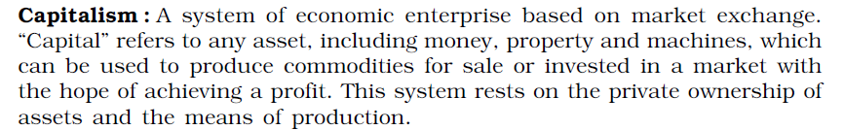 | 2
13. | Write any two bases of class as a system of social stratification. OR  Write any two bases of caste as a system of social stratification.  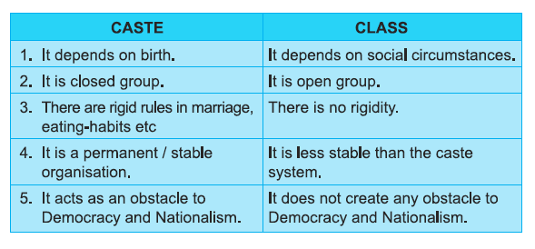 | 2
 | SECTION C
14. | a. Differentiate between Sociology and Economics.  1. Sociology studies the different parts of society as a whole whereas Economics studies only the economic part of society.  2. The viewpoint of sociology is extensive while economics is a special science related to the economic aspect of human beings.  3. The approach of sociology to study relationships is collectivistic whereas the perspective of economics is individualistic.  4. Sociology uses quantitative and numerical methods whereas economics derives facts using inductive and deductive methods.  5. Economic phenomena are constantly determined by all sorts of social needs and activities and they are constantly redefining, creating, shaping and transforming social needs and activity of every kind.  OR  - How is Sociology different from Psychology.  Psychology is one of the closest subjects to sociology.  - Psychology focuses on the study of an individual’s mind, whereas sociology studies society.  - Psychology is the science of behaviour, mental processes, experience whereas Sociology is the study of social behaviour of man in society.  - Psychology is more interested in intelligence, learning, emotions, motivation, memory etc. Sociology is interested in relationships between family, marriage, kinship values and norms.  - Psychology studies about hopes and fears of individuals, sociology studies about social institutions in an organised way.  - Social psychology bridges the gap between two subjects and studies how individuals behave collectively in society. | 4
15. | 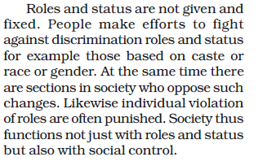  a. What do we understand by the term ‘role’ in sociology? (2 marks)  Role refers to the expected behaviour of an individual who holds a certain status and it is the status which determines the behaviour pattern, obligations and privileges. Role is the dynamic aspect of status. The functions which an individual performs in society are referred to as ‘Role taking’ and the functions that he/she is expected to perform are known as ‘Role expectations’  - State the two basic forms of status and briefly explain these with an example  (2 marks) | 4
 | SECTION D
16. | In what ways did the Industrial Revolution lead to the birth of Sociology in Europe?  The Industrial Revolution began in Britain in the late 18th and early 19th centuries. It marked the beginning of the scientific age and led to changes in social lives of people.  - Before industrialization the rural sector was important. The chief occupation was farming and weaving. Society was hierarchical, status and class conscious. People worked according to their needs, factors like daylight and deadlines.  - Industrialization meant there was a systematic application of science and technology. Huge factories were set up for large-scale production of goods like textiles and iron and steel. New forms of economic activity gave rise to capitalism as the pursuit of profit was geared to markets in distant colonies.  - There was a dramatic change in social life as a new working class emerged. Farmers migrated to industrial cities, which were characterized by overcrowded housing, poor sanitation and general squalor.  - An indicator of this new society was the emergence of “clock time”. The tempo of work was set by the clock and calendar. Factory production meant that work began punctually and people worked in shifts for set hours and were paid according to what they produced.  - Karl Marx and Durkheim were appalled at the degradation of factory workers and became concerned with the scientific analysis of developments in industrial society. Sociology was born as a result of this as it was based on the understanding of “science of a new modern industrial world”.  OR  What is social control? Do you think the modes of social control in different spheres of society are different? Discuss.  What is social control? Do you think the modes of social control in different spheres of society are different? Discuss.  Answer: The term ‘social control’ refers to the social process by which the behaviour of individuals or group is regulated. Society is a harmonious organization of human beings and expected to perform their functions accordingly. In order to exist and progress society has to exercise certain control over its members, such controls are termed as social control. Consequently, social control is pervasive feature of any society.  Social control helps to restrain the unwanted behaviour of the individuals and the groups. It is an influence, exercised by society for promoting the welfare of the group as a whole.  Social control varies from one society to another because each society has its own rules and norms. Different types of societies like individualistic society or collectivistic societies have different expectations (roles) from their members.  Indian cultural values and general standards of life are different from western individualistic society. Therefore both the societies have different patterns of social control. We emphasize on socialization whereas technologically advanced western society focuses on individual liberty.  Social control considers customs, traditions, rituals, rules and sub rules according to the social demands. Accordingly in that particular society, family system, marriage system, positive and negative conventions, religion and education systems develop. Members of that particular society should conform these systems. Society develops an appropriate social control for that particular society. | 6

